Guidelines for Videoarticle Production

The following provides guidelines for preparing your Videoarticle.

Structure and Content
Videoarticles must have the following structure:

Cover: This includes the title, authors, and affiliations. A template including the cover and the section titles are available at link:
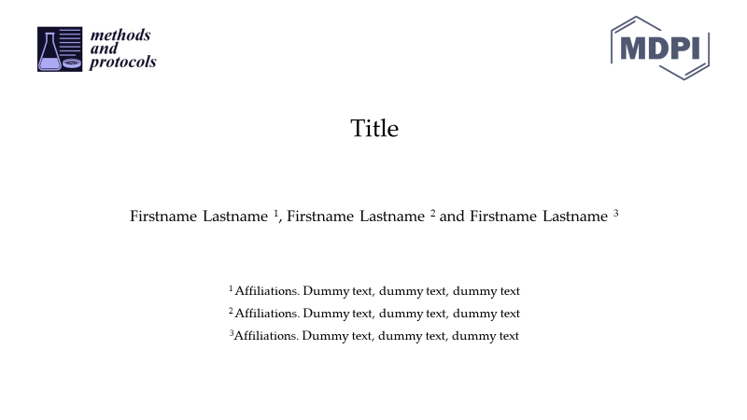

Introduction: Briefly state the goal and motivation of the method/protocol, including its innovation, applications and benefits.

Experimental section: All important experimental procedures should be presented along with the main results. Fully describe and show all the experimental steps, including critical procedural issues to producing a reproducible result. The time needed to complete the whole procedure once a researcher has mastered the protocol/technique/method should be clearly stated.
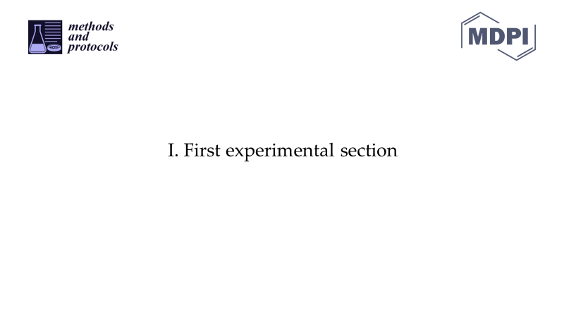
Conclusions. Give the main conclusions derived from the method/protocol development.

Submission Guidelines
Before submission, compress the video and make sure the uncompressed file meets the maximum file size criterium (see video specifications).
The compressed Videoarticle should be submitted along with a Protocol or Benchmark paper, and any relevant supplementary material.

Video Specifications
Your Videoarticle must meet the following specifications:

Format | .mp4, .webm, .ogg
Max. file size | 500 Mb
Length | <10 min

