Methods and protocols. Guidelines for videoarticle production

Videoarticles are detailed step-by-step experimental demonstrations that illustrate new methods or protocols, and introduce the material and equipment operation required to conduct an experiment described in a Protocol or Benchmark paper. They are intended to be a tool to increase the reproducibility and visibility of newly developed protocols/methods and can also be used as teaching aids. Videoarticles demonstrating new methods/protocols in any of the scientific disciplines covered by Methods and Protocols are welcome.
Videoarticles will be published alongside textual methods/protocols and they will be freely accessible and downloadable. Additionally, they can be shared in Social Media, which will help increase the visibility of your research. In order for your research to reach the broadest audience possible, only videoarticles in English will be considered for publication. All videoarticles will be checked for editorial suitability and quality, as well as for coherence with the Protocol or Benchmark paper.
Please note that your video shouldn’t contain any music/sounds nor overt product promotion; for more tips on videoarticle preparation, please check the file “Tips for videoarticles”. Before preparing your videoarticle, please read the following sections.

Structure and Content
Videoarticles should be prepared according to the following recommended structure:
Cover. This includes the title, authors, and affiliations. A template including the cover and the section titles can be provided by the Editorial Office (mps@mdpi.com) upon request.
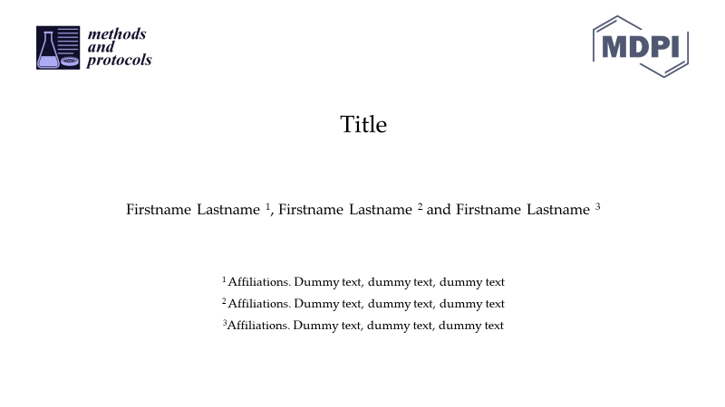

Introduction. It should briefly state the goal of the method/protocol, the question(s) it may help answering, and its innovation, applications and advantages.
Experimental section. All the important experimental sections should be presented separately and include highlights of the main results. Fully describe and show all steps required to perform the experiment demonstrated and mention those critical procedural issues to be considered in order for the procedure to be successful and reproducible.
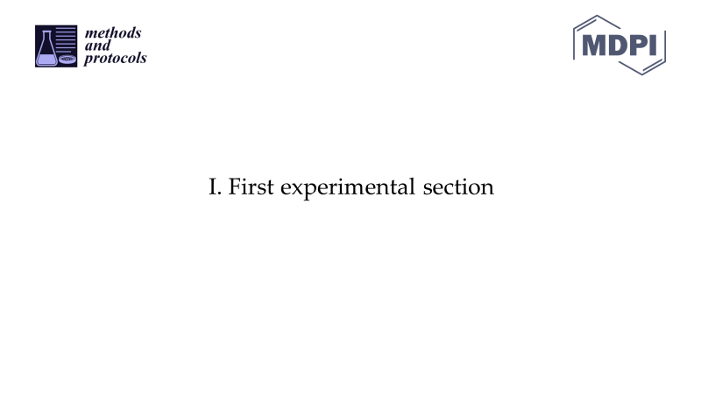
Conclusions. Highlight the main conclusions and the time needed to complete the whole procedure once a researcher has mastered the protocol/technique/method.

Submission Guidelines
Before submission, compress the file and make sure the uncompressed video meets the maximum file size criterium (see video specifications).
The compressed Videoarticle should be submitted along with a Protocol or Benchmark paper, and any relevant supplementary material.

Video Specifications
Minimum standards for video and audio quality must be met. When preparing your Videoarticle, you must make sure it meets the following specifications:

Format | .mp4 (H.264 codec), .webm, .ogg
Max. file size | 500 Mb
Length | <10 min; however, more time can be granted if needed

