The Digital Curtain: A Subject of Sustainability Science
Roland W. Scholz

The quest for sustainability – An impact of the Industrial Age
Historically, the term environment received a new connotation in Herbert Spencer’s 1855 book, The Principles of Psychology [1], when he generalized it from meaning a single organism’s adaptation to its own particular environment to “life as a whole corresponding to the environment” [2]. This concept is also included in Ernst Haeckel’s 1866 definition of environment as the “total science of the relationship of the organism with the outer world” [3]. Both terms were generated at a time when the Industrial Age in Europe was approaching its climax. The world was facing radical change, with tremendous increases in mining, fossil-energy use, environmental depletion, occupational health problems, and the working class’s search for social justice. The Industrial Revolution altered the economic, social, and environmental structures of large regions of the planet in less than a century.

The term sustainability, first outlined in the 1992 Brundtland Report for the World Commission on Environment and Development [4], can be viewed as a conceptual tool for coping with the negative impacts of the Industrial Age that spread throughout the globe. Sustainable development is a social process with the aim of coping with the visible fragility and vulnerability of environmental and social systems. Sustainable development includes a norm-, value-, and intention-driven process of resilience management. This becomes evident through a systemic interpretation of the Brundtland definition, which conceives of sustainability as (a) an ongoing (social) inquiry on system-limit management (i.e., what must be done to ensure that the resilience of environmental, social, and economic is not endangered) in the frame of intra- and intergenerational justice.’ We can see that the sustainable development of a social process (a) calls for a sound scientific assessment of the vulnerability of systems (b) but is also a normative venture.

The Digital Revolution – More fundamental than the Industrial Revolution
The Digital Revolution is transforming and can potentially destabilize the Earth system in a manner similar to that of the Industrial Revolution. Yet it is happening much more rapidly and in an even more fundamental manner. Digital data-processing technologies play the role of fossil-energy-driven machines. But digital technologies go beyond machine-based automatization and the amplification of human impacts on the material world. Artificial intelligence is amplifying, augmenting, simulating, and substituting human perception, computation, and rule-based inference in an increasing field of activities that go beyond chess- or go-like situations. Based on this, the automatization of industrial processes with the assistance of intelligent machines or robots changes industries, and web-based platform economics including virtual money (such as Bitcoin, introduced in 2009) are going to change economics. Likewise, digital social media are altering interpersonal communication, relationships, group formation, and information acquisition in a fundamental manner. This is presented in Figure 1 and discussed in the “Special Issue on Sustainability and Digital Environments.”

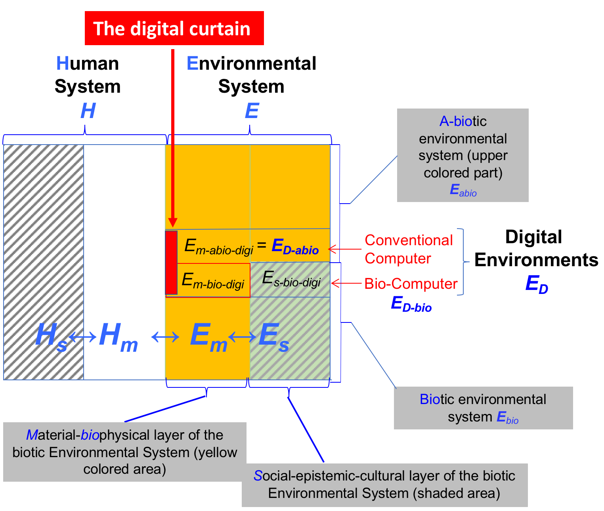
Figure 1. The digital curtain as interface between human systems and environmental systems (adapted from [5, 6], see cover illustration)

DNA is a genuine quaternary number-based digital concept. Genetic engineering opens up new doors in the human–environment relationship. One of these is targeted evolution. The random nature of the mutation process, which does not depend on whether a particular mutation is useful, is substituted. Genetic engineering allows for producing a seemingly unlimited number of genetic modifications. But it is also possible to manipulate E. coli cells to build them into electronic computers. As such, biocomputers can be seen as a new form of decision making biotic entity (see [5] and Figure 1) .

The digital curtain calls for a redefinition of humanity
A recent Japanese science expert roundtable [7] suggested that the Digital Revolution requires a redefinition of humanity. If we conceive of humanity as “the totality of attributes which distinguish humans from other beings” [8], a main issue is linked to a multifunctional digital curtain. The interaction of the human being with it's a-biotic, biotic, and social environment becomes modulated by a digital technology layer. The modulation functions in both directions and refers to signals that the human-biophysical layer wants to send to the environment and to environmental stimuli. Signals and stimuli are received by sensors, stored in digital form, and then become subjects of transformation, classification, and computation-based processing. Digitalized and processed environmental stimuli sent to the human sensory system and are perceived not in a modular but in a modulated manner – by the human sensory organs. The immediate environment takes on a digital nature.

According to Bandura, “people create social systems, and these systems, in turn, organize and influence people’s lives” [9]. The symbolizing capacity differentiates humans from other species. Yet, but and technological co-evolution becomes a new quality resulting from the digital interface, curtain, or vaulting and its symbols The mind receives artifactual, digitally shaped, partly evolutionary uncommon and reductive stimuli. Artifactual also means that the digital interface is designed and operated by (other) humans, in particular the Internet, social media, and other forms that ICT provides. Thus, the digital curtain is a subject of political, economic, and social interest and can become an instrument of nudging and manipulation. The digital curtain may empower humans in their interactions with the environment. However, it also changes social structures and may increase the social divide or environmental impacts. We argure that this and thus the topic sustainable digital environments is a genuine subject of sustainability science.

References
1. Spencer, H., The principles of psychology. 1855, London: Longman, Brown, Green, and Longmans.
2. Scholz, R.W., Environmental literacy in science and society: From knowledge to decisions. 2011, Cambridge: Cambridge University Press.
3. Haeckel, E., Generelle Morphologie der Organismen. Vol. 2. 1866, Berlin: Georg Reimer.
4. Brundtland, G.H., et al., Our common future, in UN Documents 1987, UN: New York.
5. Scholz, R.W., Sustainable digital environments: What major challenges is humankind facing? Sustainability, 2016. 8(8): p. 726.
6. Scholz, R.W., et al., Unintended side effects of the digital transition: European scientists’ messages from a proposition-based expert round table. Sustainability, 2018.
7. Sugiyama, M., et al., Unintended side effects of digital transition: Perspectives of Japanese Experts. Sustainability, 2017. 9(12).
8. Merriam Webster, Humanity, in Webster's Third New International Dictionary, Unabridged. 2018, Merriam Webster: Springfield, MA.
9. Bandura, A., Toward a Psychology of Human Agency. Perspectives on Psychological Science, 2006. 1(2): p. 164-180.

http://www.mdpi.com/2071-1050/10/6/2001

